**Testing Document:**



**Table of Contents**

# Test Case 1: testingSimulatorGUIClickingBtns()

# Test Case 2: testingSimulatorGUILabels()

# Test Case 3: testingButtonWrongImgPath()

# Test Case 4: testConfiguration()

# Test Case 5: TalkBoxConfigurationTest()

**Test Case 1:** testingSimulatorGUIClickingBtns()

This test will check if each of the audio buttons in TalkBotSimulator can be successfully clicked, the TalkBotSimulator is tested in its default state where there are 12 audio buttons.

This test case was derived by looking at the GUI during run time and then questioning if each of these buttons can be correctly clicked.

The test was implemented by iterating through each of the buttons in **track1** and **track2** (track1 and track2 are arrays of buttons for each of the two categories) and seeing if they would click using the **doClick()** method. Passing this test shows that all the buttons in the simulator can be clicked.



This test covers testing for the majority of the following classes:

TalkBotSimulator (96%), Buttons(79.5%), BBody(88%) and so it’s a good step forward to completely testing the TalkBotSimulator and its helper classes (Buttons and BBody) completely.

**Test Case 2:** testingSimulatorGUILabels()

This test will if check if all of the labels in the TalkBotSimulator GUI match what was originally tended. Specifically, it checks the labels for the 2 category buttons as well as the labels for each of the 12 audio buttons.

This test case was derived by keeping track of what the labels for each of the buttons in in the TalkBotSimulator GUI should be and comparing it with what actually occurs at run time.

The test was implemented by noting down what is expected for the audio labels in each category into the arrays **track1Expect** and **track2Expect** and then comparing it with what we get at run time for each button label by using the **getText** method on each button to get that button’s label. This doesn’t increase coverage but does check more aspects of the GUI to make sure it is running as expected. Having checked all the buttons and labels in the TalkBotSimulator we know now that it is fully tested.

**Test Case 3:** testingButtonWrongImgPath()

This test checks if an exception is thrown and handled when an invalid image path is passed to the Button constructor.

This test case was derived in order to check the error handling of the Button class.

The test was implemented by calling the Button constructor with an invalid image path and then testing to see if the Boolean method **validImgPath()** returns false which it should when the image path is incorrect as defined in the Button class. This makes the coverage testing on the Button class 100%. Thus, this should be sufficient testing for the Button class because all possible scenarios of the class use were covered.



**Test case 4:** testConfiguration()

This test will check to see if all the methods in the configuration class are working correctly. The configuration class is the backend of the configuration app, it will be used to configure the TalkBotSimulator and as such it has methods such as setBtns, getBtns, setBtnName, etc.

This test case starts by creating an instance of the configuration, called config, which should set the values of the TalkBotSimulator to our default configuration using the methods setAudioName(), setBtnName(), setImagePath(). Based on the values we passed our default configuration of our TalkBotSimulator should look like the below images:

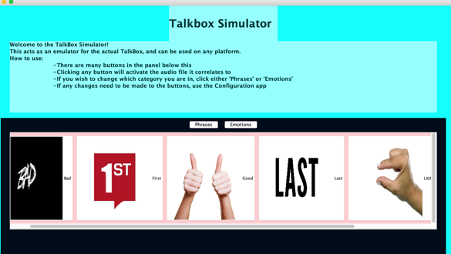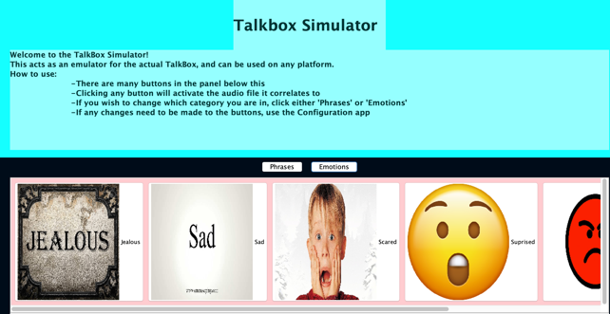

Now in order to test whether our configuration was actually able to do this correctly we start by testing the method getNumberOfAudioButtons() which should return 12 as we programmed only 12 audio buttons (6 in each category).

Now we test if the total number of buttons is 14 as it should be (12 audio buttons and 2 category buttons) by checking if the output of the method config.getTotalNumberOfButtons() will return 14.

Next we test if the setAudioName() method actually worked correctly by comparing the values of the audio file names in the configuration instance config, which we get as a 2d array from the method config.getAudioFileNames() with the expected audio file names ("bad.wav","first.wav","good.wav","last.wav","little.wav","long.wav"). Passing this test proves that we were able to set audio correctly.

Next we remove a button using config.Removebtn(1,6) and then we test to see if the new array of button names is equal to {"Bad","First","Good","Last","Little"} indicating the last position was removed. Since it is, we can say that the Removebtn method works.

Lastly we try to add a button using config.Addbtn(1, "Long", "long.wav", "Images/long.png"). To test if this method worked we test if the button names in the array **set1BtnNames** (the original value of the buttons before we added and removed because we removed the “Long” button and now were adding it again) and the array **config.getSet1Buttons()** (the current names of the buttons) are the same. We also test if audioFileNamesExpected array (array of the original audio file names) and the config.getAudioFileNames() are the same. Since they were the same we know that the Addbtn method works.

This testing covers everything in the configure class except the main method which was only used to create the default TalkBotSimulator and so it is sufficiently tested.



**Test case 5:** TalkBoxConfigurationTest()

This test covers the test of the TalkBoxConfigurationGUI, by testing the methods used by the class.

The buttons in the GUI for this class were tested using the **doClick()**. This would simulate the click action on the buttons in the configuration GUI. The buttons that were tested by this are add, remove, Apply, and audioPreview. The other buttons could not be clicked as they would launch JFileChooser and halt the testing.

Lastly, this class was tested by using its addButton() and removeButton() methods. Calling these methods launch the JPanel that is meant to be opened upon the call of these buttons and the method and GUI components of this class are clearly working as all components are covered under the tests and it does not fail any of the test.



Overall the coverage for the testing is 77.4 % and considering the GUI components that were not testable in the configuration class and the System.out.print method in configuration that didn’t require testing, it is safe to say this project is well tested and safe for public use for its first launch.

